Ewalt Volschenk

Week 9: practical
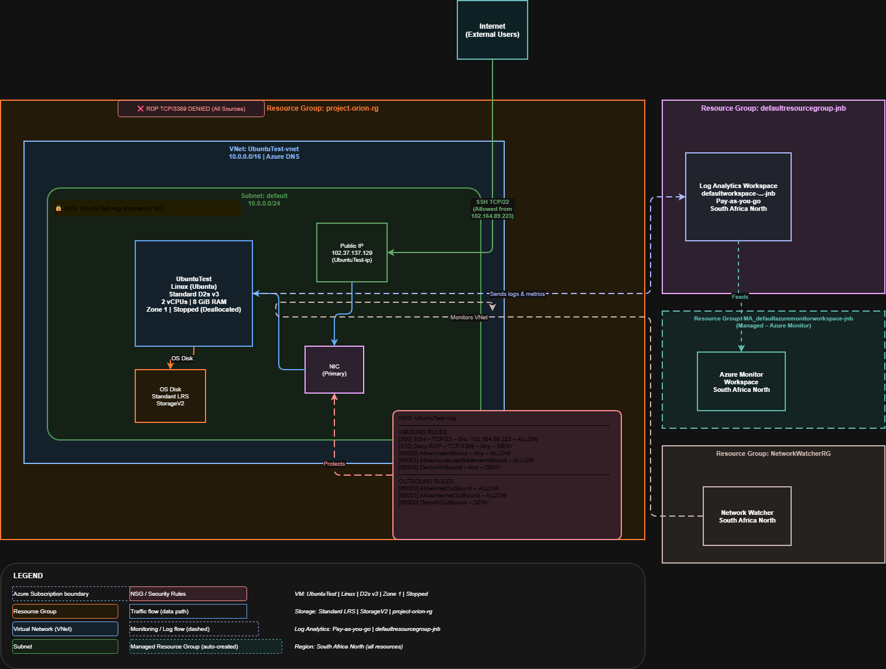

Section 2
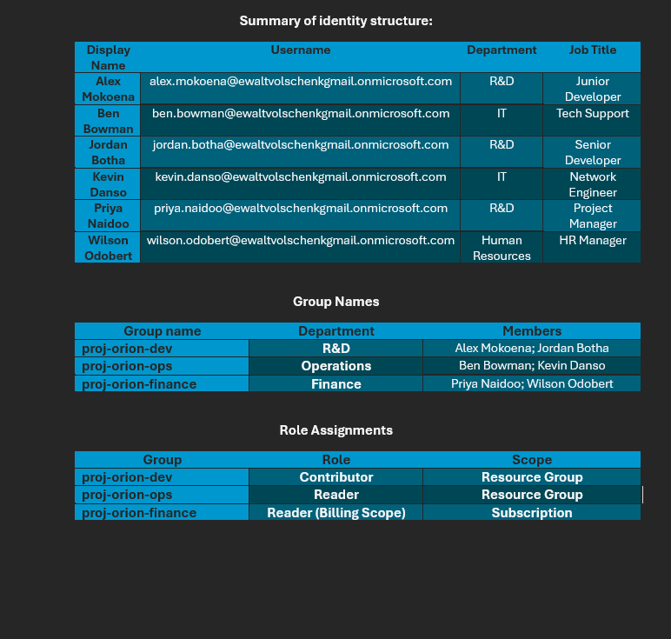

Direction | Port / Protocol | Source / Dest | Action | Justification
Inbound | 22 | My IP address | Allow | Permits secure remote management of the VM. Using SSH on port 22 for Linux VMs
Inbound | 80 | Any | Allow | Allows users on any network to access the web application hosted on the VM over HTTP which uses port 80.
Inbound | Any | Any | Deny | Explicitly blocks all inbound traffic not matched by a higher-priority Allow rule. This enforces least-privilege for network traffic.
Outbound | Any | Internet | Deny | Prevents VMs from sending data to external internet destinations.

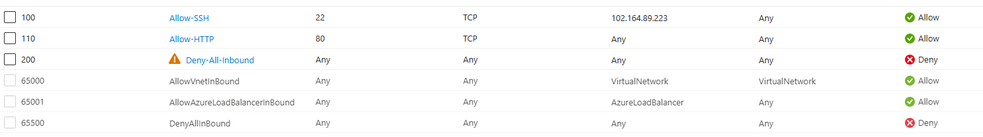

Section 3:
I configured an alert to issue an email alert to the administrator (me) when CPU usage exceeds 80%. I chose this because it leaves space for workloads to use the CPU while preventing excessive usage. All monitoring data is stored in a Log Analytics Workspace. The default retention period for a Log Analytics Workspace is 30 days at no extra cost. Platform metrics collected through Metrics Explorer are stored separately in the Azure Monitor metrics database and retained for 93 days by default.To access historical data after the default retention window, you can extend the workspace retention period in the Log Analytics Workspace settings. There are 3 metrics being monitored, CPU usage, Network out total and Disk write.

Section 4
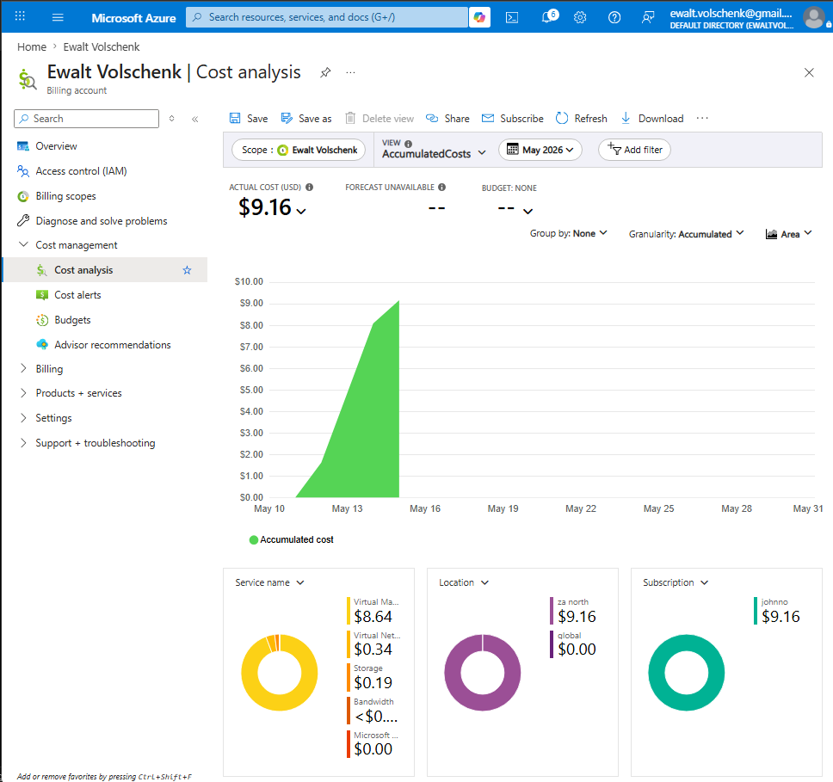
As seen in the screenshot above the total to date is about $9.16. The projected final cost for the month isn’t available currently but a manually calculated estimate is around $54.90. I optimised cost by choosing an appropriate SKU for the VM as well as stopping the VM when there is no workload running. The only resources with meaningful costs are my VM, the VNET for the VM as well as my storage account.

